**AutoHotkey Prelab Instruction**

Hi, we are Jonny, Luca and Vicky and we will present how to use “*AutoHotkey”* this week. We encourage you to install AutoHotkey application before this lab. It’s only 2 steps and it will take you only 2 minutes. ^o^”

Note: There is no equivalent version for mac user, so you can either install it on your virtual machine or fine a partner to work with.

**Step1: Download it**

Go to AutoHotkey website and download installer to your computer.

Short-cut: <https://autohotkey.com/download/>

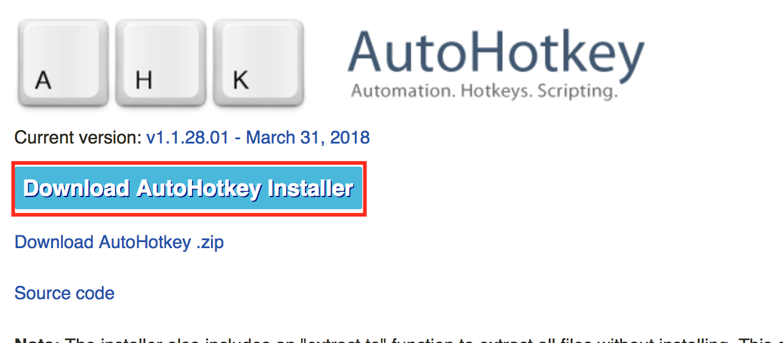

**Step2: Install it**

Run the Installer and Click *Express Installation*.

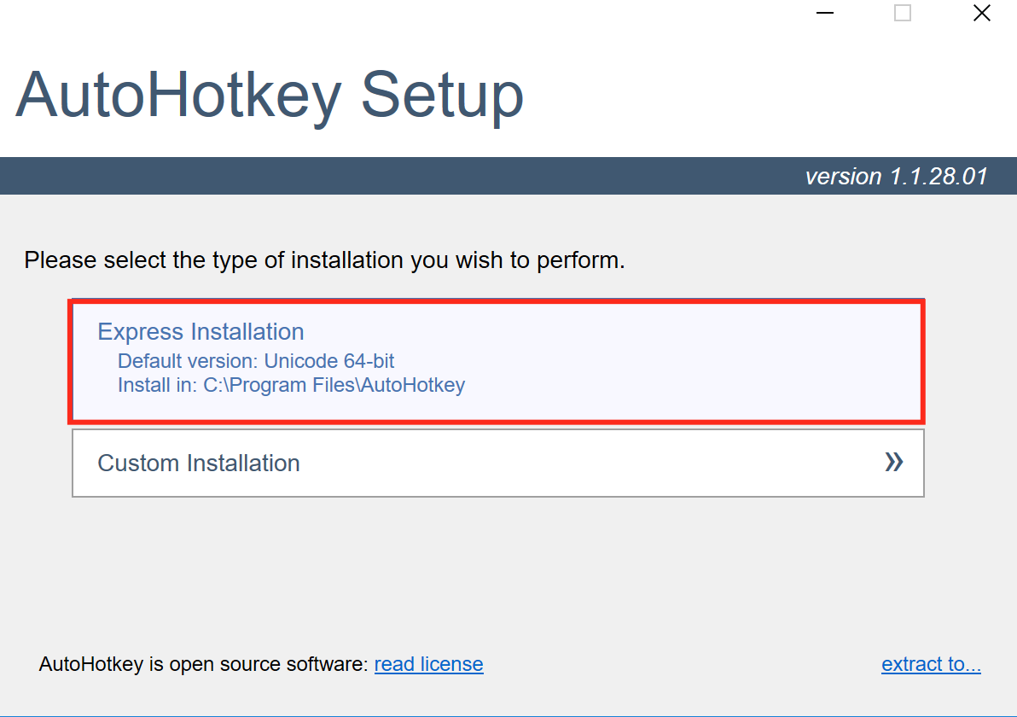

Check your program list. You can see AutoHotkey on your folder.

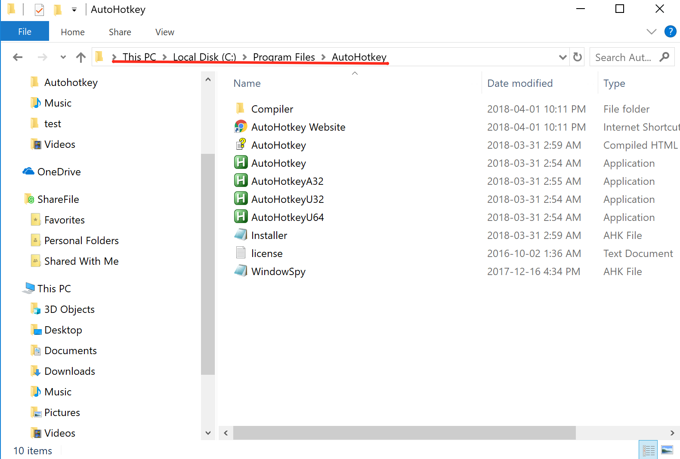

**Step3: Download our Package**

Download the Package we prepared for you.

<https://drive.google.com/drive/folders/11gLaDbzROho6UGLLVmqjagX7ZppMR6jg?usp=sharing>

You will need:

* 02 Autohotkey Demo.pdf
* CST_Hotkeys_before.ahk
* Example folder (to see the answers and more example.)

So, you’ve set up your computer for this lab. Nice!